**Wireframe Document**

**Investment Analytics**

**Revision Number - 1.2**

**Last Date of Revision - 30/12/2023**

**Anand Shrivastav**

WIREFRAME DOCUMENT DESIGN

**Document Control**

|  |  |  |  |
| --- | --- | --- | --- |
| **Date** | **Version** | **Description** | **Author** |
|  |  |  |  |
| 31/07/2023 | 1.0 | Introduction, | Anand Shrivastav |
|  |  | Problem Statement |  |
|  |  |  |  |
| 06/08/2023 | 1.1 | Dataset Information, | Anand Shrivastav |
|  |  | Architecture |  |
|  |  | Description |  |
|  |  |  |  |
| 30/12/2023 | 1.2 | Final Revision | Anand Shrivastav |
|  |  |  |  |



**Introduction& Problem Statement**

Investment analysts are financial professionals who evaluate securities, stocks, bonds, and other financial assets. They identify potential investments for purchasing, research business financials, and advise clients. They also contribute to financial decision-making through in-depth analyses of market trends and performance.

and

Investment is a game of understanding historic data of investment objects under different events but it is still a game of chances to minimize the risk we apply analytics to find the equilibrium investment

To understand the Foreign direct investment in India for the last 17 years from 2000-01 to 2016-17. This dataset contains sector and financial year-wise data of FDI in India

Sector-wise investment analysis

Year-wise investment analysis

Find key metrics and factors and show the meaningful relationships between attributes.

Do your own research and come up with your findings

I n v e s t m e n t A n a l y t I c s

WIREFRAME DOCUMENT DESIGN

**We Performed Exploratory Data Analysis on Jupyter Notebook and then created a Tableau Dashboard.**

1. **Total Sectors in Dataset**



1. **Sectors Name from Dataset**

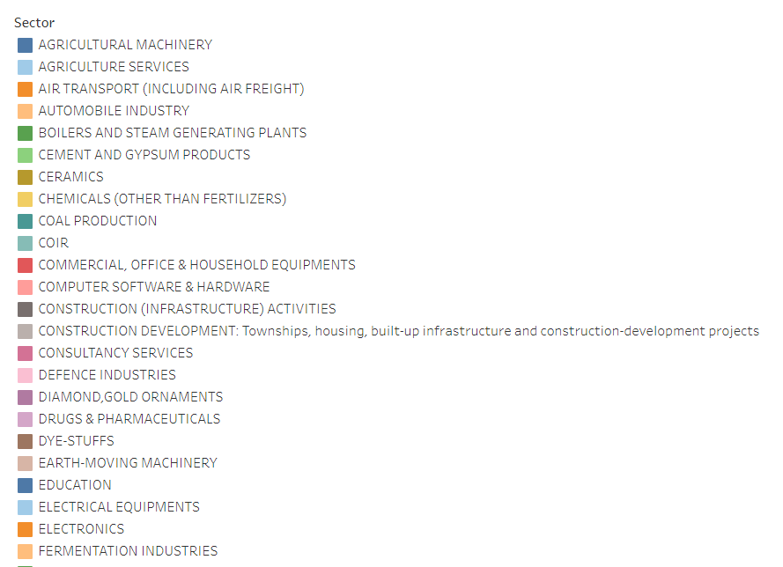

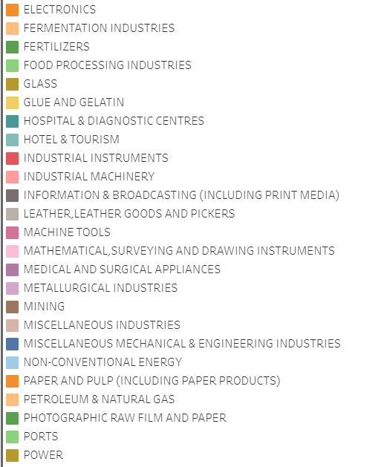

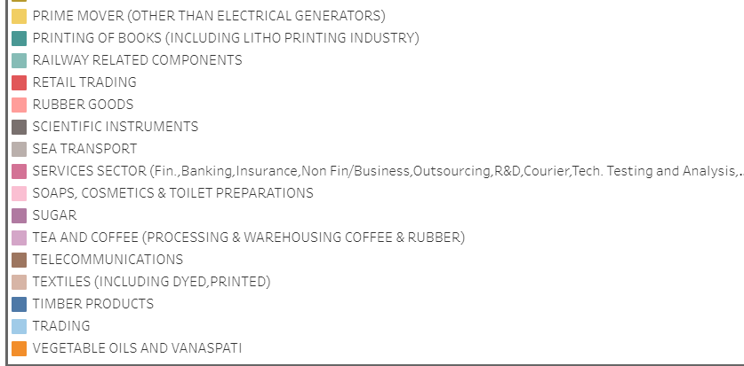

1. **Full Dashboard of Sector Wise Investment**

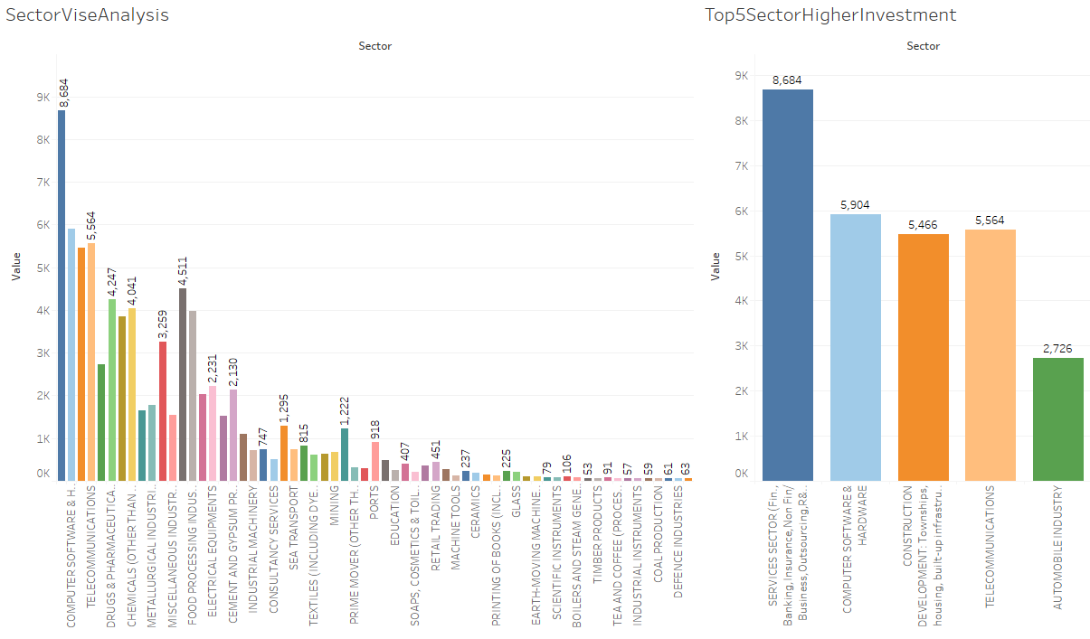

Top 5 sector with higher investment

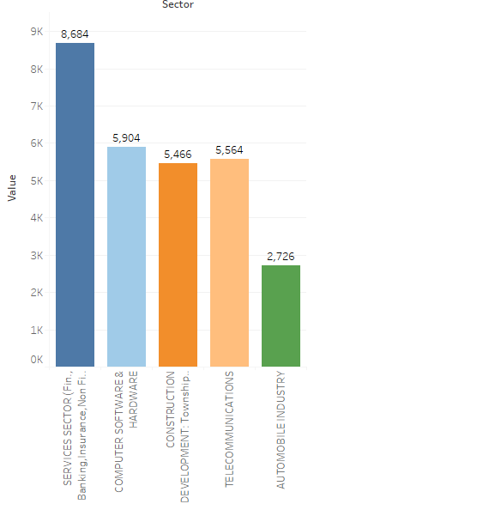

**Overall DashBoard Of Sector Wise Investment -**



**Year Wise Investment**

